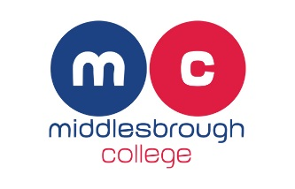

Middlesbrough Football Club Foundation
Kicks Programme
Volunteer Recruitment
VOLUNTEER PROVIDER:
Middlesbrough Football Club Foundation
VOLUNTEER ROLE:
Volunteer Assistant Coach
PURPOSE OF THE ROLE:
To assist in the delivery of the Kicks Football Programme ran by Middlesbrough Football Club Community Foundation that delivers weekly football sessions around Middlesbrough to young people.

MAIN TASKS:
As an assistant coach you will be required to support the head coach in tasks which may include setting up equipment, welcoming young people, supporting football skills, drills and matches, supporting with warm up and cool downs, encouraging the young people to take part.
REQUIRED SKILLS, QUALITIES & EXPERIENCE:
You must be passionate and enthusiastic about working with young people and helping them get active. You don’t need any prior skills, or experience as you will be provided with training and mentored throughout your volunteer placement.
WHERE & WHEN:
Evenings located at sites across Middlesbrough and Stockton. Days and locations to be confirmed based on your availability and the programmes requirements.
COMMITMENT REQUIRED:
Successful applicants will be required to commit to attending sessions on a weekly basis for a minimum of 15 weeks (2 hours per session). This is to provide you with the best possible development opportunity and also support you in attaining the required volunteer hours for your college course.
TRAINING & SUPPORT PROVIDED:
You will be funded through FA training in the following:
- Managing challenging behaviour (before you start the placement)
- How to conduct yourself as a coach (before you start the placement)
- Potential FA level 1 (dependant on hours completed)
SELECTION PROCEDURE:
As we have limited spaces you need to apply for this popular position. Once you have applied you will be invited to an induction/informal interview day held at Middlesbrough Football Stadium.

